CINEMA TICKET BOOKING SYSTEM

# A MINI PROJECT REPORT

***Submitted by***

**SANTHOSH KUMAR R 220701253**

In partial fulfillment for the award of the degree of

**BACHELOR OF ENGINEERING IN**

**COMPUTER SCIENCE**

**RAJALAKSHMI ENGINEERING COLLEGE RAJALAKSHMI NAGAR**

**THANDALAM CHENNAI-602105**

**2024**

**BONAFIDE CERTIFICATE**

Certified that this project report “**CINEMA TICKET BOOKING SYSTEM**” is the bonafide work of **“SANTHOSH KUMAR R (220701253)”**

who carried out the project work under my supervision.

**Submitted for the Practical Examination held on**

**ABSTRACT**

The *Cinema Ticket Booking System* is a web-based application developed to facilitate seamless online booking of cinema tickets for users. Utilizing PHP, HTML, CSS, JavaScript, and MySQL, the system provides features such as movie browsing, showtime selection, seat reservation, and secure payments. The system also supports real-time updates on ticket availability and booking confirmation.

Cinema administrators are equipped with tools for managing movie schedules, tracking ticket sales, and generating reports. This dual-purpose functionality enhances user convenience while optimizing administrative efficiency. By integrating modern web technologies, the system aims to provide a user-friendly, secure, and scalable solution to meet the demands of digital transformation in the entertainment sector.

# INTRODUCTION

* 1. **INTRODUCTION**

The Cinema Ticket Booking System represents a significant leap in modernizing the way tickets are booked for movies. By transitioning from the conventional manual ticket counters to a robust digital platform, this system redefines convenience for both customers and administrators. Users can effortlessly browse available movies, select preferred showtimes, and reserve their seats in real-time, all from the comfort of their devices. This innovative approach eliminates long queues, minimizes errors, and enhances customer satisfaction through a streamlined booking process.

Built on a solid foundation of PHP for backend operations, the system ensures reliable performance and secure handling of essential functionalities such as user authentication, payment processing, and dynamic updates of seat availability. Complemented by modern frontend technologies like HTML, CSS, and JavaScript, the platform provides a responsive and intuitive interface, ensuring seamless usability across various devices including desktops, tablets, and smartphones.

The system also caters to cinema administrators by offering powerful tools for managing operations. Administrators can efficiently update movie schedules, monitor ticket sales in real-time, and make adjustments to showtimes or seat availability as needed. Additionally, automated reporting and notification features enhance the operational efficiency of cinemas by providing actionable insights and timely updates to customers.

In bridging the gap between cinemas and their audience, the Cinema Ticket Booking System not only simplifies the booking experience but also boosts audience engagement and streamlines overall operations. This comprehensive solution is a testament to how technology can transform traditional practices into highly efficient, user-friendly processes, benefiting all stakeholders involved in the cinematic experience.

* 1. **OBJECTIVES**
* **Streamline Ticket Booking**

The primary aim is to replace the traditional, manual ticket booking process with a more efficient, user-friendly digital platform. By enabling users to browse available movies, check showtimes, and reserve seats online, the system minimizes waiting times and eliminates the hassle of physical ticket counters. This streamlined approach ensures a more enjoyable and stress-free experience for customers.

* **Enhance User Experience**

To make the platform more engaging and intuitive, features such as real-time seat selection and live updates on ticket availability are integrated. Users can visualize and choose their preferred seats directly from the platform, providing a personalized and interactive booking process. This focus on user convenience ensures satisfaction and encourages repeat usage.

* **Improve Administrative Efficiency**

The system includes powerful administrative tools that allow cinema managers to handle their operations with ease. Administrators can update movie schedules, manage showtimes, and track ticket sales in real time. Additionally, the platform allows for quick adjustments to accommodate changes in demand or unforeseen circumstances, ultimately saving time and resources.

* **Secure Transactions**

Security is a top priority for the Cinema Ticket Booking System. By employing robust encryption methods and secure payment gateways, the platform ensures that users’ sensitive information, such as personal details and payment data, is protected. This builds trust and encourages users to adopt the system with confidence.

* 1. **MODULES**

## User Module:

* + **Registration and Login:** Enables users to create accounts and securely log in to access personalized features.
  + **Profile Management:** Allows users to update their personal information and preferences.
  + **Movie Browsing & Showtime Selection**: Facilitates easy navigation of available movies and showtime options.
  + **Seat Reservation**: Provides an interactive interface for real-time seat selection and booking.
  + **Booking History**: Displays a detailed record of all past bookings for user reference.

## Admin Module:

* **Admin Login:** Offers secure access for administrators to manage the system.
  + **Movie & Schedule Management**: Enables the addition, update, or removal of movies and schedules.
  + **Sales Report Generation**: Provides tools for generating detailed sales and performance reports.
  + **User Management**: Allows administrators to monitor and manage user accounts and activities.

## Payment Module:

* + **Integration with Multiple Payment Gateways**: Supports secure transactions through various payment methods.
  + **Invoice Generation**: Automatically creates and provides invoices for completed bookings.

## Notification Module:

* + **Email and SMS Alerts**: Sends automated notifications for booking confirmations, reminders, and updates.

## Feedback and Review Module:

* + **User Feedback Submission**: Allows users to share reviews and rate their booking experience.
  + **Review Management**: Enables administrators to moderate and respond to user feedback.
  + **Insights Generation**: Compiles feedback into actionable insights for service improvement.

## Promotions and Offers Module:

* + **Discount Management**: Facilitates the creation and application of promotional codes and discounts.
  + **Offer Notifications**: Sends alerts to users about ongoing deals and special offers.
  + **Loyalty Programs**: Tracks user activity to provide rewards for frequent bookings.

## Analytics and Reporting Module:

* + **User Behavior Analysis**: Tracks trends in user preferences, such as popular movies or showtimes.
  + **Performance Metrics**: Provides insights on system performance, ticket sales, and customer engagement.
  + **Custom Report Generation**: Enables administrators to create detailed reports for strategic planning.

1. **SURVEY OF TECHNOLOGIES**
   1. SOFTWARE DESCRIPTION

## Survey of Technologies for Cinema Ticket Booking System

To create a feature-rich, secure, and scalable Cinema Ticket Booking System, several technologies across the frontend, backend, database, and security domains are considered. The following provides an overview of the technologies suitable for its development:

## Frontend Technologies

* + HTML5/CSS3:
    - HTML5 provides semantic elements to structure the web pages effectively, including features like forms for user login, menu browsing, and checkout.
    - CSS3 is used to enhance the visual appearance, enabling responsive layouts, transitions, and animations to ensure the application is user- friendly and attractive on all devices.
  + JavaScript:
    - Adds interactivity by enabling features like real-time seat selection, live updates for availability, and form validation on the client side.
  + Bootstrap:
    - A CSS framework that simplifies creating a responsive design. It provides pre-designed components such as buttons, modals, and grids, ensuring a consistent and mobile-friendly user interface.
  + jQuery:
    - A lightweight JavaScript library that simplifies event handling, DOM manipulation, and AJAX integration, improving interactivity and responsiveness of the interface.

## Backend Technologies

* + PHP:
    - A server-side scripting language used for handling business logic, including processing bookings, managing user authentication, and interacting with the database for operations like schedule updates and payment processing.
  + AJAX:
    - Allows real-time communication between the client and server, enabling dynamic updates for booking status, seat availability, and ticket confirmations without page reloads.

## Database Management

* + MySQL:
    - A robust relational database system for storing structured data such as user details, movie schedules, seat availability, and transaction records. Its compatibility with PHP ensures smooth data handling.
  + SQL Queries:
    - SELECT Retrieves movie schedules, seat maps, and booking histories.
    - INSERT Saves new bookings, user registrations, and transaction details.
    - UPDATE Modifies seat statuses, schedule details, or user preferences.
    - DELETE Removes expired booking data or inactive user accounts.

## Security Technologies

* + HTTPS/SSL:
    - Implements SSL (Secure Socket Layer) encryption to protect data transmissions between the client and server, safeguarding sensitive details like user credentials and payment information.
  + Data Validation and Sanitization:
    - Server-side validation and sanitization in PHP to prevent SQL injection and XSS (Cross-Site Scripting) attacks.
  + Authentication and Authorization:
    - Password hashing for secure user authentication.
    - Role-based access control (RBAC) to restrict access to admin and user- specific features.

## Development Tools

* + XAMPP:
    - A local development environment that includes Apache, PHP, and MySQL. XAMPP is essential for hosting, developing, and testing the system locally before deployment.
  + Visual Studio Code:
    - A popular code editor supporting multiple programming languages and extensions, ideal for handling HTML, CSS, JavaScript, and PHP during development.

## Testing Tools

* + Postman:
    - Used for testing APIs to ensure seamless communication between the frontend and backend for operations like booking tickets, fetching schedules, and confirming payments.
  + Selenium:
    - An open-source tool for testing the user interface across multiple browsers and ensuring the food ordering system is responsive, functional, and user- friendly.

## Requirements and Analysis for Cinema Ticket Booking System

1. **Introduction**:

The **Cinema Ticket Booking System** is designed to provide a user-friendly, efficient, and secure platform for customers and administrators to manage movie bookings, schedules, and related services seamlessly. Below is a detailed breakdown of the system’s functional and non-functional requirements, along with an analysis of its key components and workflows.

## Functional Requirements:

* 1. **User Management:**
     + Customer Registration and Login:

Users can register an account, providing personal details, and log in securely to access personalized services.

* + - Customer Profile Management:

Users can update their profile information, view booking history, and manage preferences for notifications and alerts.

## Menu Management:

* + - **Movie Browsing**:

The system should display available movies, including details such as showtimes, genres, ratings, and descriptions.

* + - Real-Time Updates:

Movie schedules, seat availability, and ticket pricing should be dynamically updated in real time.

## Ticket Booking and Checkout:

* + - **Seat Selection and Booking**:

Customers should be able to select available seats from an interactive seating map and proceed to book tickets.

* + - Order Summary:

A detailed booking summary, including seat numbers, pricing, and applicable discounts, should be generated before payment.

* + - Payment Gateway Integration:

A secure interface for processing payments via multiple payment options, including credit cards, digital wallets, and cash on delivery.

## Notification and Alerts:

* + - Booking Confirmation:

The system should send booking confirmations via email or SMS.

* + - **Event Notifications**:

Users should receive alerts for special offers, schedule changes, or upcoming movie releases based on preferences.

## Administrative Functions:

* + - **Movie Schedule Management**:

Administrators should be able to add, update, or remove movie listings and schedules.

* + - **Sales and Report Management**:The system should generate detailed reports on ticket sales, top-performing movies, and audience demographics.
    - **User Management**:

Admins can view, modify, or deactivate user accounts and monitor system usage.

* + - **Feedback Moderation**:

Manage user feedback to ensure service quality and customer satisfaction.

## Non-Functional Requirements:

* 1. **Performance:**
     + The system should handle simultaneous bookings and payment processes efficiently, even during high-demand periods.

## Reliability:

* + - The system uptime should be 99% or higher, ensuring uninterrupted access for users.
    - Regular data backups and recovery mechanisms should be in place to prevent data loss.

## Scalability:

* + - The system should scale to accommodate increased traffic during festivals or special promotions.

## Usability:

* + - The interface should be intuitive, allowing customers to browse movies, select seats, and book tickets with ease.

## Security:

* + - Sensitive data, such as personal details and payment information, should be encrypted during transmission and storage.
    - The system should be protected against common vulnerabilities such as SQL injection and cross-site scripting.

## Compliance:

* + - The system should comply with relevant regulations, such as data privacy laws (e.g., GDPR) to safeguard customer information.

# RESULTS AND DISCUSSION

## Output screen

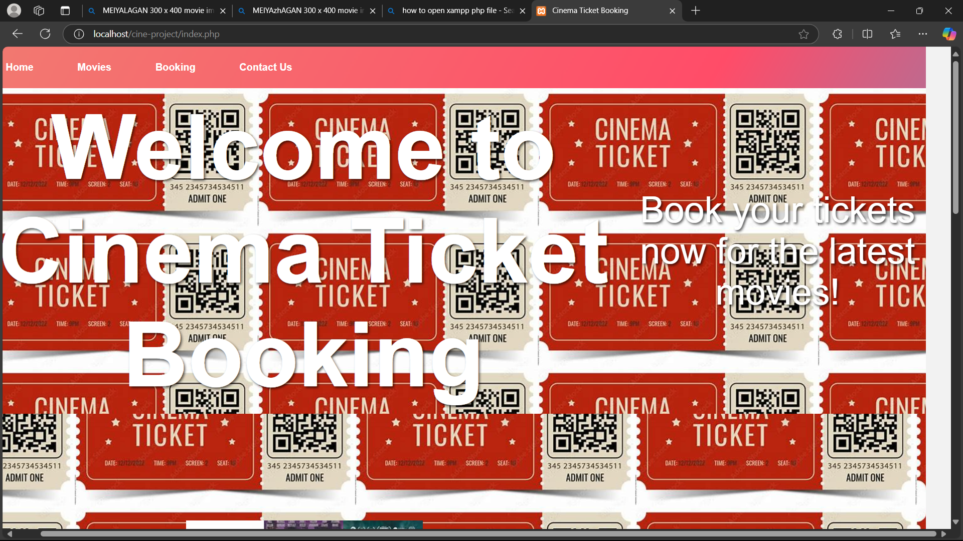

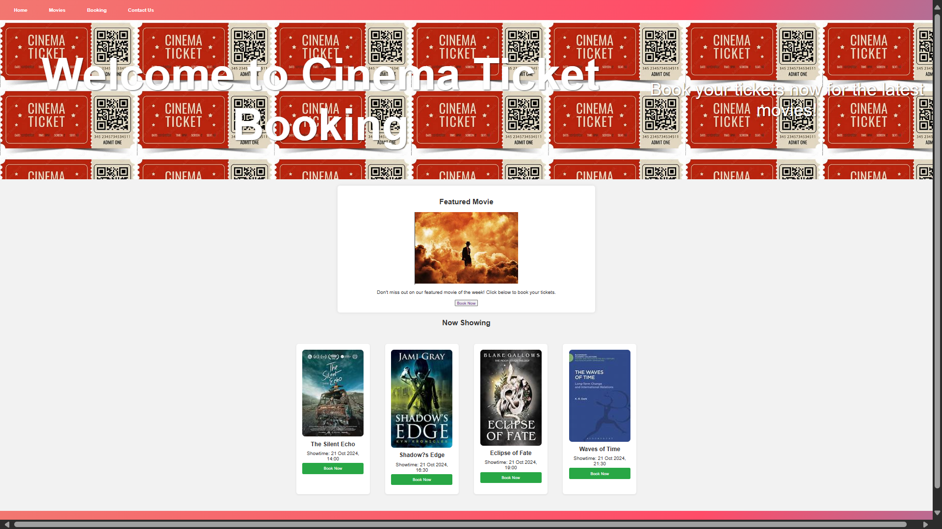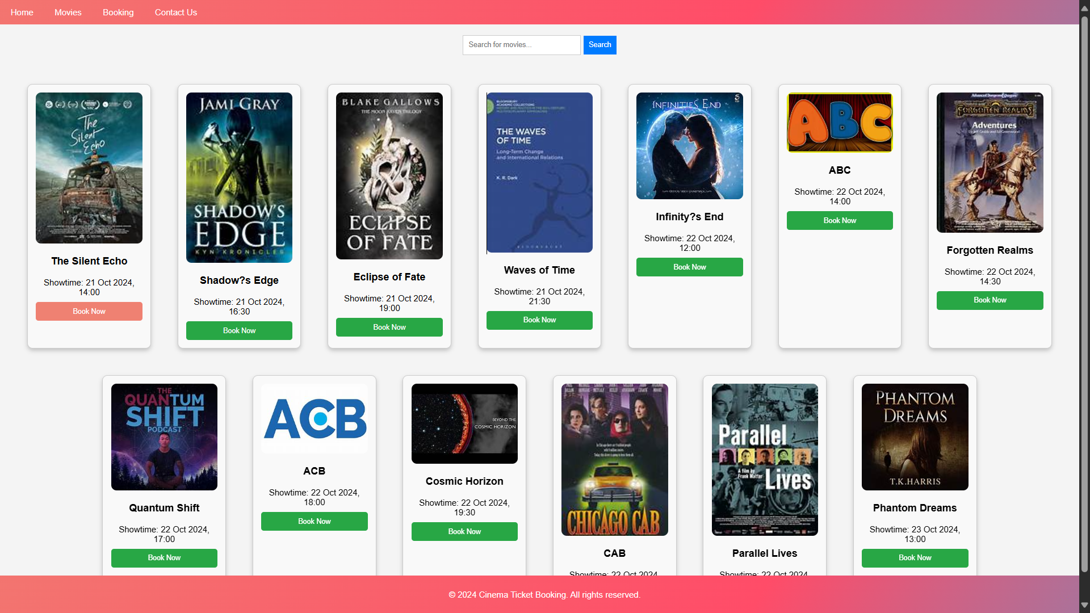

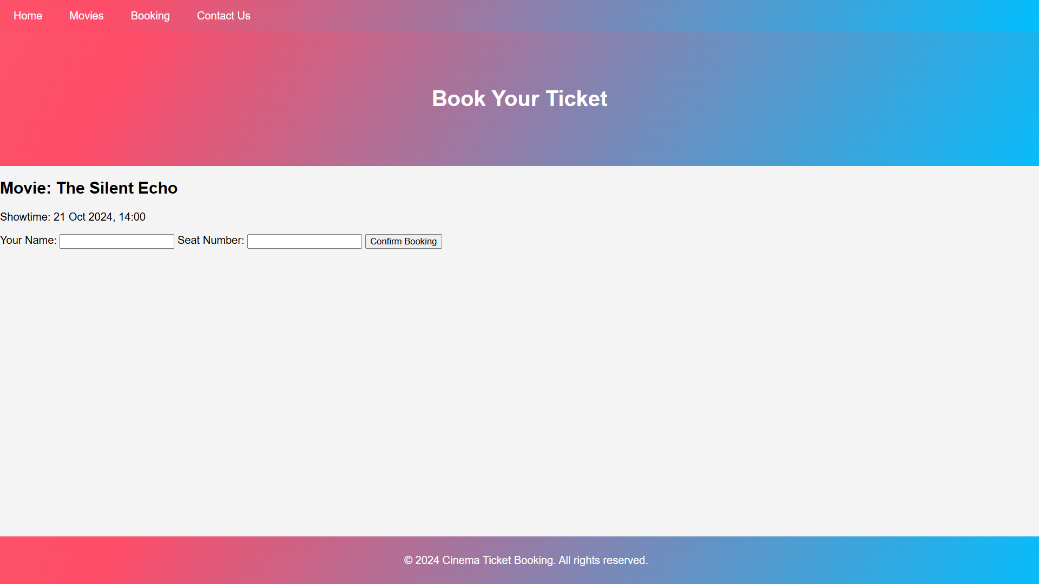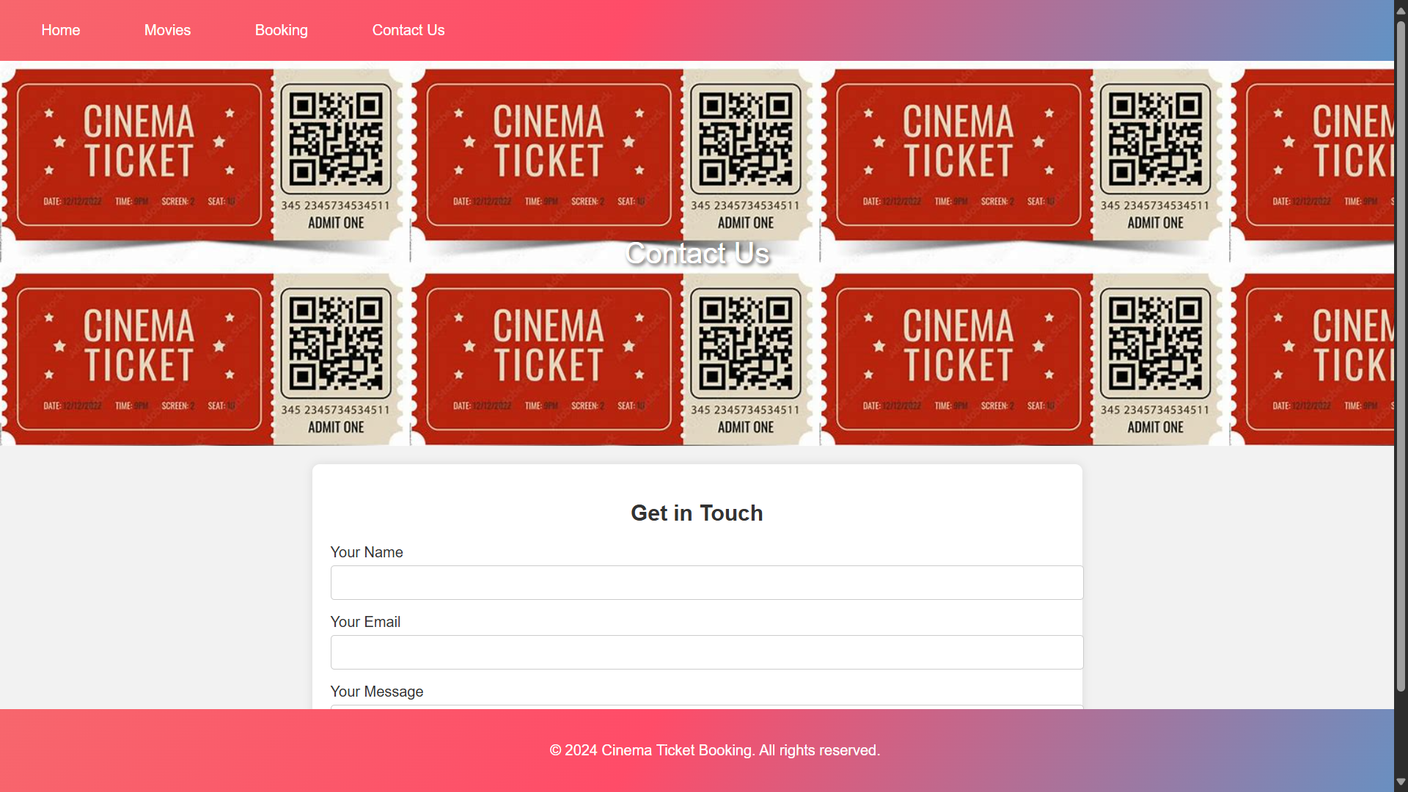

# CONCLUSION

The **Cinema Ticket Booking System** is an intuitive platform that revolutionizes the process of booking movie tickets and managing cinema operations. It allows customers to effortlessly browse movies, select showtimes, reserve seats, and make secure payments, while providing real-time updates on seat availability and booking status. For cinema administrators, the system streamlines schedule management, ticket sales tracking, and report generation, improving operational efficiency and reducing manual errors. By storing user preferences and offering personalized notifications, the system enhances the customer experience. Additionally, it supports promotional features like discounts and loyalty programs, encouraging user engagement. In summary, the Cinema Ticket Booking System modernizes the movie-going experience, ensuring convenience, reliability, and efficiency for both customers and cinema operators.